Saturday, January 24, 2015
Ruth’s site: www.houstoncode.weebly.com
Karen’s site: http://codehouston.edublogs.org/

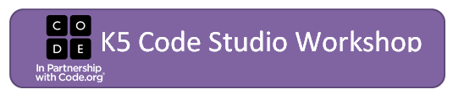
Code.org K 5 Teacher Affiliates Heather Saksa and Chinma Uche
ruth.hanson@duchesne.org --- knorth@wt.net
ruth.hanson@duchesne.org/karen.north@duchesne.org
ruth.hanson@duchesne.org/karen.north@duchesne.org
ruth.hanson@duchesne.org/karen.north@duchesne.org
Join Workshop at: http://studio.code.org/join/_________
8:00-8:30 |  | Registration
 |  | Teacher Account Sign-Up
 |  | Network /Crowd sourcing – Bead Count
8:30-8:50 |  | Introduction, Housekeeping and Bingo
8:50-9:20 |  | K-5 Courses overview and PuzzleTime!
9:20-9:30 |  | Break
9:30-9:45 |  | EQUITY – Black Girls Code Video and discussion
11 9:45 -10:30 |  | Teacher/Learner/Observer  Build a Foundation C1L9 p. 49  Graph Paper Programming
10:30-11:30 |  | Planning for today’s TLO Lessons (3 lessons)  Binary Bracelets, Get Loopy, Relay programming
11:30 – 12:15 |  | Lunch – Provided by CDW-G
12:30-1:30 |  | TLO – Unplugged Lessons by Teachers
1:30- 1:50 |  | Human Knot: CS Themes: Communication, Creativity, Perseverance, Debugging and Problem Solving
1:50 -2:00 |  | Break
2:00 -2:45 |  | Teacher Dashboard Explanation  Code.org Support/Office hours  Integration with Commitment and Family Photo
2:30-3:00 |  | Paired Programming  Video and puzzles as pairs
3:00 |  | Thank you!

Karen
Ruth

